《CHURCH NEWS 教 會 消 息》

- 羅省粵語教會歡迎您參加每安息日的聚會。
The Los Angeles Cantonese Seventh-day Adventist Church welcomes you to our weekly meetings on the Sabbath Day.
- 歡迎劉漢新醫生及王守美營養師蒞臨証道。
A warm welcome to Dr. Benjamin Lau & Esther Lau, RND for sharing God’s Word with us today.
- 聖餐禮聯合崇拜聚會下安息日 11 時舉行，安息日學於10 時舉行。
Combined Worship and Communion Service next Sabbath will begin at 11 am. Sabbath School at 10 am.
- 9月份堂董會將於下安息日下午 3時召開。
September board meeting next Sabbath at 3:00 pm.
- “以食物來治療癌症”講座將於今日下午二時舉行，主講者：王守美營養師
“Healing Cancer with Food” seminar will be held today 2pm by Esther Lau, RND
- 義賣籌款將於今日下午三時於教會大門舉行，捐款用作教會事工用途。
Church Ministry Fundraising will be held today at 3 pm at church front entrance
- 追月交誼晚會今日下午 6 時在交誼廳舉行，請向李貴好姊妹報名。同場將進行拍賣為教會事工籌款。
Mid-Autumn Festival Social Night will be held today at 6 pm. Register with Maria Poon. A silent auction will be held for Church Ministry Fundraising.

《陽光大道 Sunshine Boulevard》網上廣播 Podcast
環節 | 主持 |  | 本週一 (9/16) | 下週一 (9/23)
健康生活 | Maria, Rosana |  | 食品儲存 (3) | 食品儲存 (4)
社會透視 | Cecil |  | 生活指數 | 無家可歸
空中花園 | Tim, Megan, Jeffery |  | 對世界的預言 (5) | 對世界的預言 (6)
收聽網址：http://eu.awr.org/en/listen/program/266或http://www.linguaspirita.net/cantonese
討論：http://www.facebook.com/SunshineCantonese
蘋果iPhone、iPad可進入Podcasts搜尋和訂閱，iTunes也可找到。
安息日 (9月28日) 當值表 On Duty for Next Sabbath
Sabbath School 安息日學 |  |  | Worship 崇拜 | Cantonese 粵語
司會  Chairperson |  | 胡美婷  Christina Wu | 領唱  Song Leader | 敬拜組  Praise Team
禱告/讀經Prayer/Scripture |  | 曾抑瑜  Yvonne Tang | 司會  Chairperson | 陳越珍  Rebecca Hong
聖工消息  Mission Story |  | 存心節重溫  Memory Verse Verses | 証道  Sermon | 陳韋豪  Jeffery Chan
詩歌奉獻  Special Music |  |  | 牧養禱告/讀經  Intercession/Scripture | 陳禮華  Sheridan Broyles
合班  Classes |  | 蘇美顏  Lana Lui | 執事  Deacon/Deaconess | 董麗娜/陳雅妍  Cristy / Briana

基督復臨安息日會
羅省粵語教會
Los Angeles Cantonese
Seventh-day Adventist Church
2019年9月21 日 September 21, 2019
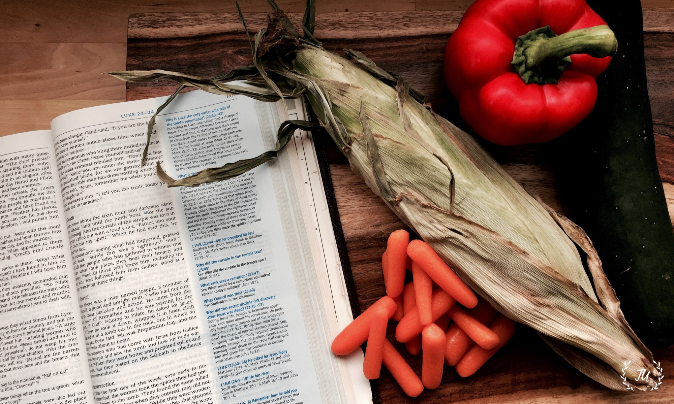

時間Time | 活動 Activity | 場地Venue | 負責人Person in charge
10:00 am | 安息日學  Sabbath School | 禮堂  Sanctuary | 朱盈欣  Delia Chu
 | 兒童聖經班  Children Sabbath School | 副堂  Chapel | 伍潔芬  Joyce Wong
 | 合班  Combined Class | 副堂  Chapel | 陳越慶  Bilta Tran
11:00 am | 聨合崇拜聚會  Combined Worship | 禮堂  Sanctuary | 講員 Speaker:  劉漢新  Benjamin Lau
12:30 pm | 交誼聚餐  Fellowship Lunch | 副堂  Chapel | 會眾  Congregation

日落時間Sunset 天普市Temple City：今日Today 6:51 pm 下星期五Next Friday 6:42 pm
聚會地點 Venue: 5537 Temple City Boulevard, Temple City
辦公室Office: 3817 Arden Dr., El Monte
郵寄地址 Mailing Address: P.O. Box 634, Rosemead, CA 91770-0634
團契網站 Website: www.lacantonese.org 電郵Email: cantonesesda@gmail.com
Facebook: facebook.com/cantonese.sda 受款名稱Checks to: L.A. Cantonese SDA Church
粵語部堂牧Pastor (Cantonese):
陳韋豪牧師 Jeffery Chan 626-677-6821 / 王溢中牧師Y.C. Wong
英語部堂牧Pastor (English):
游建睿長老 Miles Yu 626-536-3934 / 胡傳沂傳道Aidan Wu 323-629-0799
聯合崇拜聚會
Combined Divine Worship 11:00
司會Chairperson: 陳越珍Rebecca Hong
司琴Pianist: 朱盈欣 Delia Chu
翻譯Interpreters: 游建睿 Miles Yu, 馬錫強 Cecil Ma
詩歌頌讚  Song Service |  | C152-159/E282我聽主聲歡迎  I Hear Thy Welcome Voice  C276-349/E48/G6383時刻需要主  I Need Thee Every Hour  NC386每一天  E532/G718 Day By Day |  |  |  |  |  |  |  |  |  |  |  |  |  |  |  |  |  |  |  | 敬拜組  Praise Team
三一頌  Doxology |  |  | C497-497/E694/G815 讚美上帝  Praise God From Whom All Blessings |  |  |  |  |  |  |  |  |  |  |  |  |  |  |  |  |  | 會眾  Congregation
呼召禱告  Invocation |  |  |  |  |  |  |  |  |  |  |  |  |  | 劉漢新  Benjamin Lau
司會致辭  Welcome |  |  |  |  |  |  |  |  |  |  |  |  |  | 陳越珍  Rebecca Hong
崇拜詩  Hymn of Praise |  |  |  |  |  | C147-147/E272賜我聖經  Give Me the Bible |  |  |  |  |  |  |  |  |  |  |  |  |  |  | 會眾  Congregation
代禱/牧養禱告  Testimony/  Intercession |  |  |  |  |  |  | C498/E684/G641 請聽我祈禱  Hear Our Prayer, O Lord |  |  |  |  |  |  |  |  |  |  | 李月萍  Jacklyn Concepcion
報告  Announcement |  |  |  |  |  |  |  |  |  |  |  |  |  |  |  |  |  | 陳越珍  Rebecca Hong
奉獻  Offering |  |  |  |  |  | 堂費捐  Church Budget  （什一或傳道人基金請用捐款信封註明） |  |  |  |  |  |  |  |  |  |  |  |  | 曾抑琦/曾抑瑜  Kay Tang Yvonne Tang
讀經  Scripture Reading |  |  |  |  |  | 出埃及記 15：26  Exodus 15:26 |  |  |  |  |  |  |  |  |  |  |  |  | 胡傳沂  Aidan Wu
證道  Sermon |  |  |  |  |  | 聖經對於癌症的處方  Biblical Prescription for Cancer |  |  |  |  |  |  |  |  |  |  |  |  | 劉漢新  Benjamin Lau
回應詩  Hymn of Response |  |  |  |  |  |  |  |  | C289-373/ E590 信而從主  Trust and Obey |  |  |  |  |  |  |  |  |  | 會眾  Congregation
祝福  Benediction |  |  |  |  |  |  |  |  |  |  |  |  |  |  |  |  | 陳越珍  Rebecca Hong
祝福頌  Benediction Hymn |  |  |  |  |  |  |  |  |  | 主賜福你  Zyu Ci Fuk Nei |  |  |  |  |  |  |  |  |  | 會眾  Congregation
C:《讚美詩》(1965/2017)․E: Seventh-day Adventist Hymnal․G: Celebration Hymnal

安息日學
Sabbath School 10:00
 | 主理  Superintendent: |  |  |  |  |  |  |  |  |  |  |  | 朱盈欣  Delia Chu
 | 開會詩  Opening Hymn |  |  |  |  |  | C253-393/E321 我愛主耶穌  My Jesus, I Love Thee |  |  |  |  |  |  |  |  |  |  |  |  | 會眾  Congregation
 | 禱告  Prayer |  |  |  |  |  |  |  |  |  |  |  |  |  |  | 李貴好  Maria Poon
 | 聖工消息  Mission Story |  |  |  |  |  |  |  | 葬禮的轉變  Funeral Conversion |  |  |  |  |  |  |  | 陳子武  Tim Chan
 | 讀經  Scripture Reading |  |  |  |  |  |  |  |  |  | 詩篇112:4-5  Psalm 112:4-5 |  |  |  | 李貴好  Maria Poon

存心節:正直人在黑暗中，有光向他發現；他有恩惠，有憐憫，有公義。施恩與人、借貸與人的，這人事情順利；他被審判的時候要訴明自己的冤。(詩篇112：4-5)

兒童聖經章節Children’s Bible Verse: (馬太福音Matthew 7:1)
你們不要論斷人、免得你們被論斷。
Be not judges of others, and you will not be judged.

活動Program | 時間Time | 場地Venue | 註Note
禱告晚會  Prayer Meeting | 星期三 晚上六時三十分  Wednesday at 6:30 pm | 副堂  Chapel | 服務的真意旨 第四章  (626) 800-3583
口琴班  Harmonica Class | 安息日下午三時  Sabbaths 3:00 pm | 禮堂  Sanctuary | 每月第一及第三安息日  1st & 3rd Sabbaths
夏威夷小結他  Ukulele Class | 安息日下午二時三十分  Sabbaths 2:30 pm | 副堂  Chapel | 每安息日下午  Every Sabbath afternoon
結他班(初級)  Guitar Class  (Begninng) | 安息日下午三時十五分  Sabbath 3:15 pm | 教會辦公室  Church Office | 每安息日下午  Every Sabbath afternoon
結他班  Guitar Class | 安息日下午三時三十分  Sabbath 3:30pm | 禮堂  Sanctuary | 每安息日下午  Every Sabbath afternoon
團契  Can-Joy  Fellowship | 安息日下午二時  Sabbath, 2 pm | 禮堂  Sanctuary | 9月21日  September 21

每天用禱告互相守望! Daily Prayer for Each Other!
日 Sun | 一 Mon | 二 Tue | 三 Wed | 四 Thu | 五Fri
Zhan, Kerwin  詹雨辰 | Tang, Kay  曾抑琦  (家人) | Lui, Lana  蘇美顏  (家人) | Su, Luo Sheng  蘇洛生  (家人) | Wu, Aidan  胡傳沂 | Yu, Moses  游大遠  (家人)

